NACRTAJ I NAPIŠI U BILJEŽNICU:
SCHOOLWORK
MY FAVOURITE PART OF THE DAY

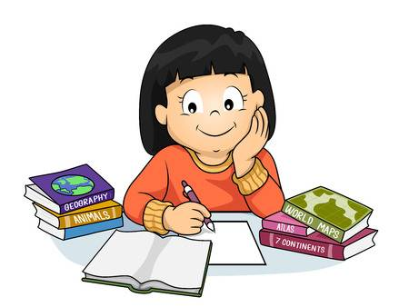 DO MY HOMEWORK - NAPISATI ZADAĆU
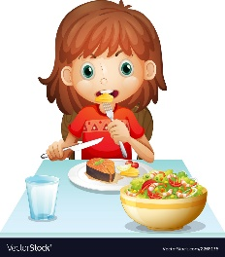 HAVE LUNCH – RUČATI
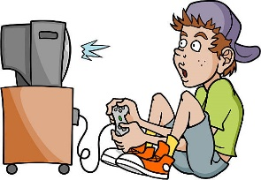 PLAY COMPUTER GAMES – IGRATI KOPJUTORSKE IGRICE
WATCH TV - GLEDATI TELEVIZIJU
HAVE DINNER - VEČERATI
GO TO BED - IĆI U KREVET

1 SPOJI PAROVE
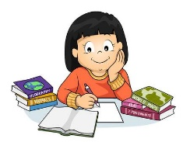 PLAY COMPUTER GAMES
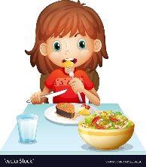 HAVE DINNER
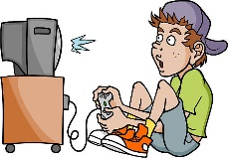 DO MY HOMEWORK
HAVE LUNCH
GO TO BED
WATCH TV

2 NACRTAJ PREPIŠI I ZAOKRUŽI TOČNE RIJEČI
a) DO MY HOMEWORK b) GO TO BED

a) WATCH TV b) HAVE LUNCH
a) PLAY COMPUTER GAMES b) HAVE DINNER
a) WATCH TV b) GO TO BED

3 PROČITAJ REČENICE I POGLEDAJ SLIKE.

IN THE MORNING
I WAKE UP.
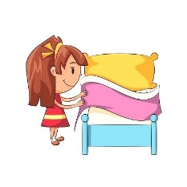 I MAKE MY BED.
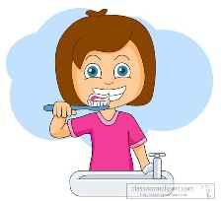 I BRUSH MY TEETH.
I HAVE BREAKFAST.
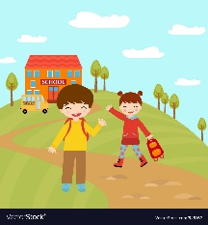 I GO TO SCHOOL.

IN THE AFTERNOON
I DO MY HOMEWORK.
I HAVE LUNCH.
I PLAY COMPUTER GAMES.

IN THE EVENING

I WATCH TV.
I HAVE DINNER.
I GO TO BED.

4 POGLEDAJ JOŠ JEDNOM ZADATAK 3. PAŽLJIVO PROČITAJ REČENICE. OBOJI TOČNE REČENICE.

IN THE MORNING
/
I GO TO BED.
I WAKE UP.
/
I HAVE BREAKFAST.
I WATCH TV.
/ /
I PLAY COMPUTER GAMES.
I GO TO SCHOOL.
/ /

IN THE AFTERNOON
I WATCH TV
I DO MY HOEWORK
/
I MAKE MY BED
I HAVE LUNCH
I HAVE DINNER
I PLAY COMPUTER GAMES
/
/

IN THE EVENING
I WAKE UP
I HAVE DINNER
/
I GO TO SCHOOL
I WATCH TV
DO MY HOMEWORK
/
I GO TO BED.
/

