UNIT 4: THE CALENDAR
LESSON 1: GUESS THE MONTHS!

- Ponoviti nazive za mjesece u godini
https://wordwall.net/hr/resource/124747
https://wordwall.net/hr/resource/397027

- Rb/ 48,49 – riješiti 1. i 2. zadatak

IZGLED PLOČE:
Schoolwork

seasons – godišnja doba
spring - proljeće

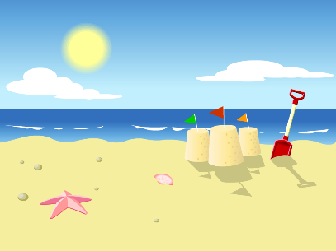 summer - ljeto
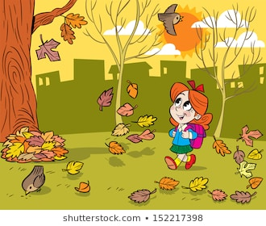 autumn – jesen
winter - zima

