Scratch Basic

Estimated duration: 1 hour 30 minutes
Age level: Primary school students
Learning Objectives, skills and competencies
By the end of this lesson, students will have learnt that:
- the computer is a machine which executes the instructions humans are giving it;
- an algorithm is a process (recipe) to resolve a problem;
- Scratch is a visual programming environment;
- some instructions are only executed if triggered by an event (event programming);
- some instructions are executed one after the other (sequential programming);

Activities and roles
Students discover the Scratch environment and create a short animated dialogue. The teacher provides instructions, monitors the class and provides assistance when necessary.
What do you need?
For the classroom:
- a video projector (or a smart board)
- (OPTIONAL) a USB key to save all projects

For each pair of students:
- a computer connected to the Internet or a computer on which the Scratch software is already installed (a Scratch icon on the Desktop is useful)
- a computer mouse

Learning space
School classroom or computer room.
Activity description

Step 1: Intro (5 minutes)

Explain that the goal of this lesson is to create an animation of a conversation between two characters. Show the class what the end result could look like by launching a Scratch project you will have created in advance. This will motivate the students.
Here is an example:
https://scratch.mit.edu/projects/179470715/

Step 2: Basic Instructions (10 minutes)

Invite students to connect to/open Scratch. If students are working online, they can find the Scratch website at https://scratch.mit.edu/ or by typing “Scratch” in a search engine (Google, for example). Next, they should click on the “Create” button.

Tip
On the desktop version, students might be prompted to install updates. It’s best to refuse and install the updates after class.
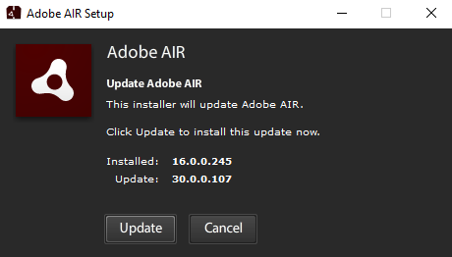
With the online version, students may be prompted to activate Adobe Flash:
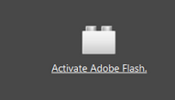
They should do so by clicking on the link and then on the button “Authorize”.
Next, show how to make the cat (the default sprite) move forward by dragging and dropping the “move 10 steps” instruction from the block palette to the script area.
Click on the instruction. The cat moves forward of 10 steps (10 pixels).
If we want the cat to move 20 steps, we can replace “10” by “20”.
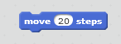
If we want to make the cat say something, we change the category of blocks to “Looks”,
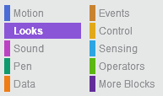
drag the instruction “say Hello! For 2 seconds” to the script area
and “snap” it to the first block.
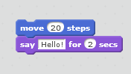
To delete a block, we drag the block back to the block palette.
Show the main sections of the Scratch environment:
- Stage (this is where the animation/game happens);
- Sprites Area (characters or objects which are programmed);
- Block Palette (set of instructions/blocks used to program the sprites);
- Script Area (where the program is “written”).
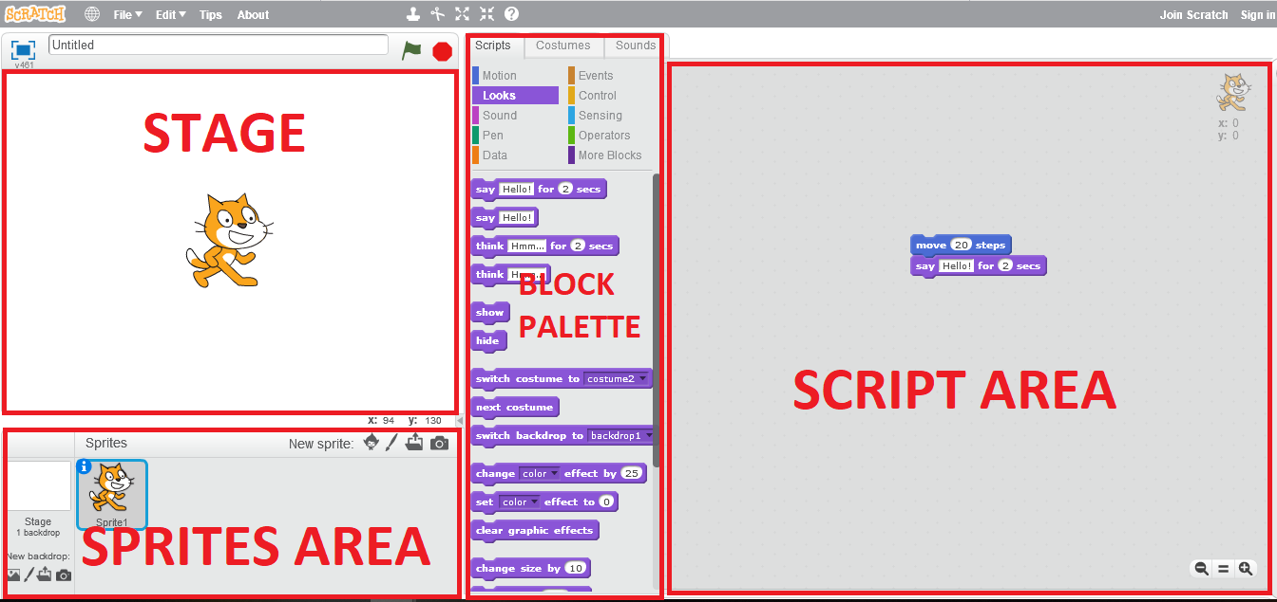

Step 3: Free Exploration (10 minutes)

Let the students explore Scratch on their own. They can test different categories of blocks.

Tip
You may want to restrict/monitor the use of the Sound category. With a large group, the sound can quickly become annoying especially when combined with loops...

Step 4: Choice of Characters (10 minutes)

Show how to delete the cat sprite by clicking with the right mouse button on the cat in the Sprites Area and selecting “delete”.
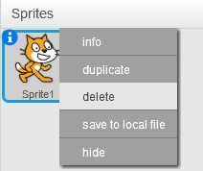
Show how to add a new character by clicking on the “Choose sprite from library” button.
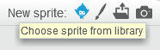
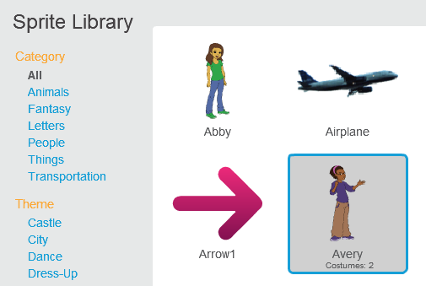
Once selected, the new sprite will appear somewhere on the Stage. You can move the character around the Stage by clicking it and dragging it to the desired position.
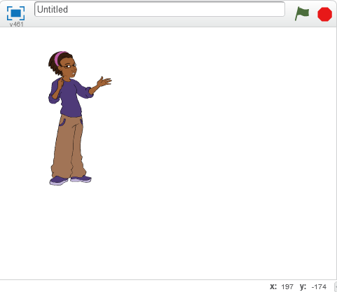
Ask the students to pick two characters and think about what they will say.

Tip
Remind the students to exchange roles. They should each take turns at controlling the mouse and keyboard.

Step 4: Choice of Background (5 minutes)

Show how to change the background by clicking on the “Choose backdrop from library” button.
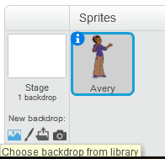
Ask the students to select a suitable background.

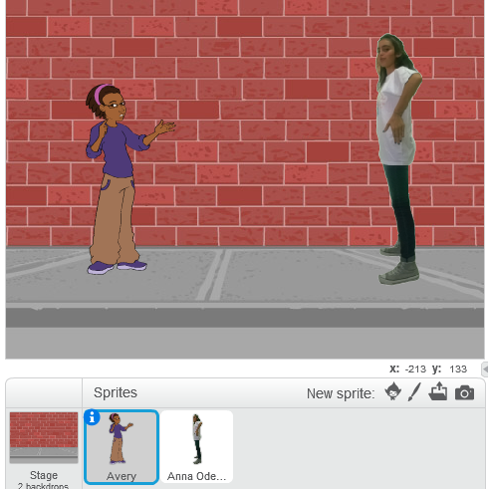

Step 5: Saving (5 minutes)

Scratch is used in the browser (online editor)
- Students should first give a name to their project:

- From the File menu, students can download the project to the computer:
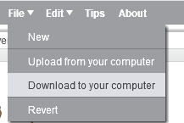

- This will create a SB2 File which can be saved on the desktop in any folder.
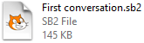

- Further changes to the project will not be saved automatically to the SB2 File. Students have to “overwrite” the file by downloading the file again (repeating the previous steps).

- Alternatively, students can save their work online (i.e. on the Scratch servers). To do so, they first have to either join Scratch or sign in.
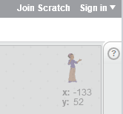

- Once signed in, the project will automatically be saved in the student’s online portfolio.
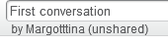

- At any point, if the « Saved » notification does not appear, students can manually save by clicking « Save now » in the File menu.

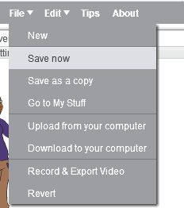

Scratch is installed locally (offline editor)
- Students can save by clicking “Save” in the File menu:
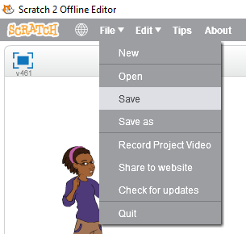

- Students will need to give a name to their project.

- This will create a SB2 File which can be saved on the desktop or any other folder.

Tips
Joining Scratch can be a long and tedious process; all the more so with large groups. We suggest you request a Scratch Teacher Account to better manage your students’ participation. See this page to learn more about Teacher Accounts.
In order for students to easily find their projects later on:
- Number the computers;
- Ask students to incorporate their names in the file names.

Step 6: Scripting a Conversation (30 minutes)

Show the students how to add an event to start the conversation.
Click on your first character, add a “When green flag clicked” block to its scripting area
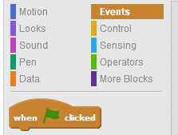

and make it say something, like so (notice that we changed the text) :
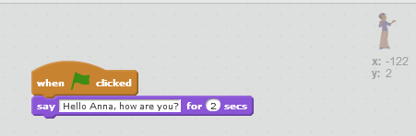
Have the second character answer. Repeat the same steps as above (don’t forget to click on the second character in the Sprite Area before you start adding the blocks).
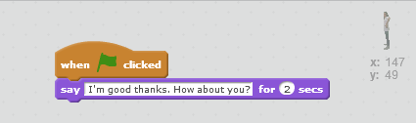
Click on the Green flag on top of the stage.
The students should notice that the two characters speak at the same time
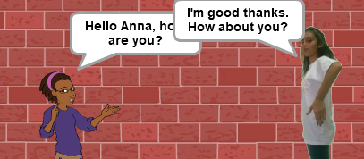
To rectify this problem, we need to use the “Wait” block.
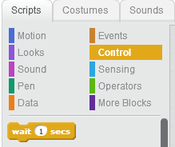
We can include the wait block in the script of the second character. Simply drag it to the right position and change the number of seconds:
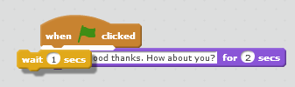
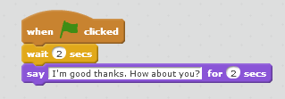
Now the characters talk in turn!
Ask the students to continue the conversation. Additionally, they can try to:
- Get the characters to move towards one another (“Motion” section);
- Change the appearance of the characters after they’ve spoken;
- Change the background after one of the character has spoken.

Notes
- Take at least an hour to get familiarized with Scratch prior to teaching this lesson. You can follow our video tutorials. You’ll see, it is lots of fun, even for adults!
- Take a few moments before the lesson to make sure all computers are connected to the Internet (if necessary) or have Scratch installed.
- This module is best suited for children aged 8 years old and above who can read and manipulate a keyboard/mouse.
- For younger children, you may consider Scratch Junior, which makes no use of text except for numbers. Note that Scratch Junior is only available on tablets (iOS, Android).
- Pair programming works best. The ideal setup is to have two students per computer, alternating every 10 minutes who controls the keyboard/mouse.
- Losing hours of work is extremely frustrating! Make sure students have a strategy to save their work. See step 5.

Have fun teaching Scratch!

Name of author: Margo Tinawi

