**OCEAN FLOOR Collage**

[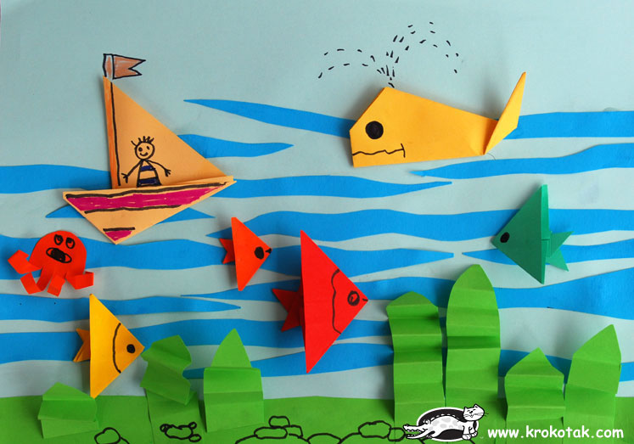](http://krokotak.com/wp-content/uploads/2009/06/75.jpg)

[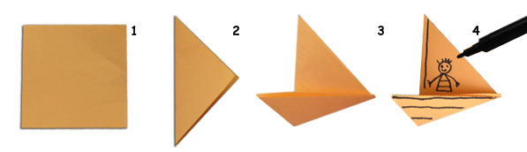](http://krokotak.com/wp-content/uploads/2009/06/sea2.jpg)

[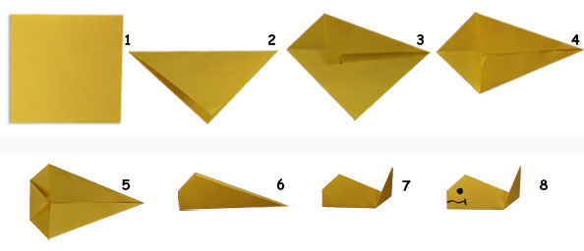](http://krokotak.com/wp-content/uploads/2009/06/sea3.jpg)

[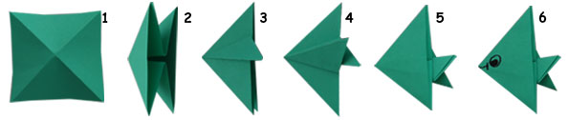](http://krokotak.com/wp-content/uploads/2009/06/sea4.jpg)